Nama: Dimas Damar Buana

NIM: 20210140135

Kelas: C

UCP 1 Pengembangan Desain Web

1. Link Github:

<https://github.com/DimasLuxMundi/UCP1_PDW_135.git>

1. Code

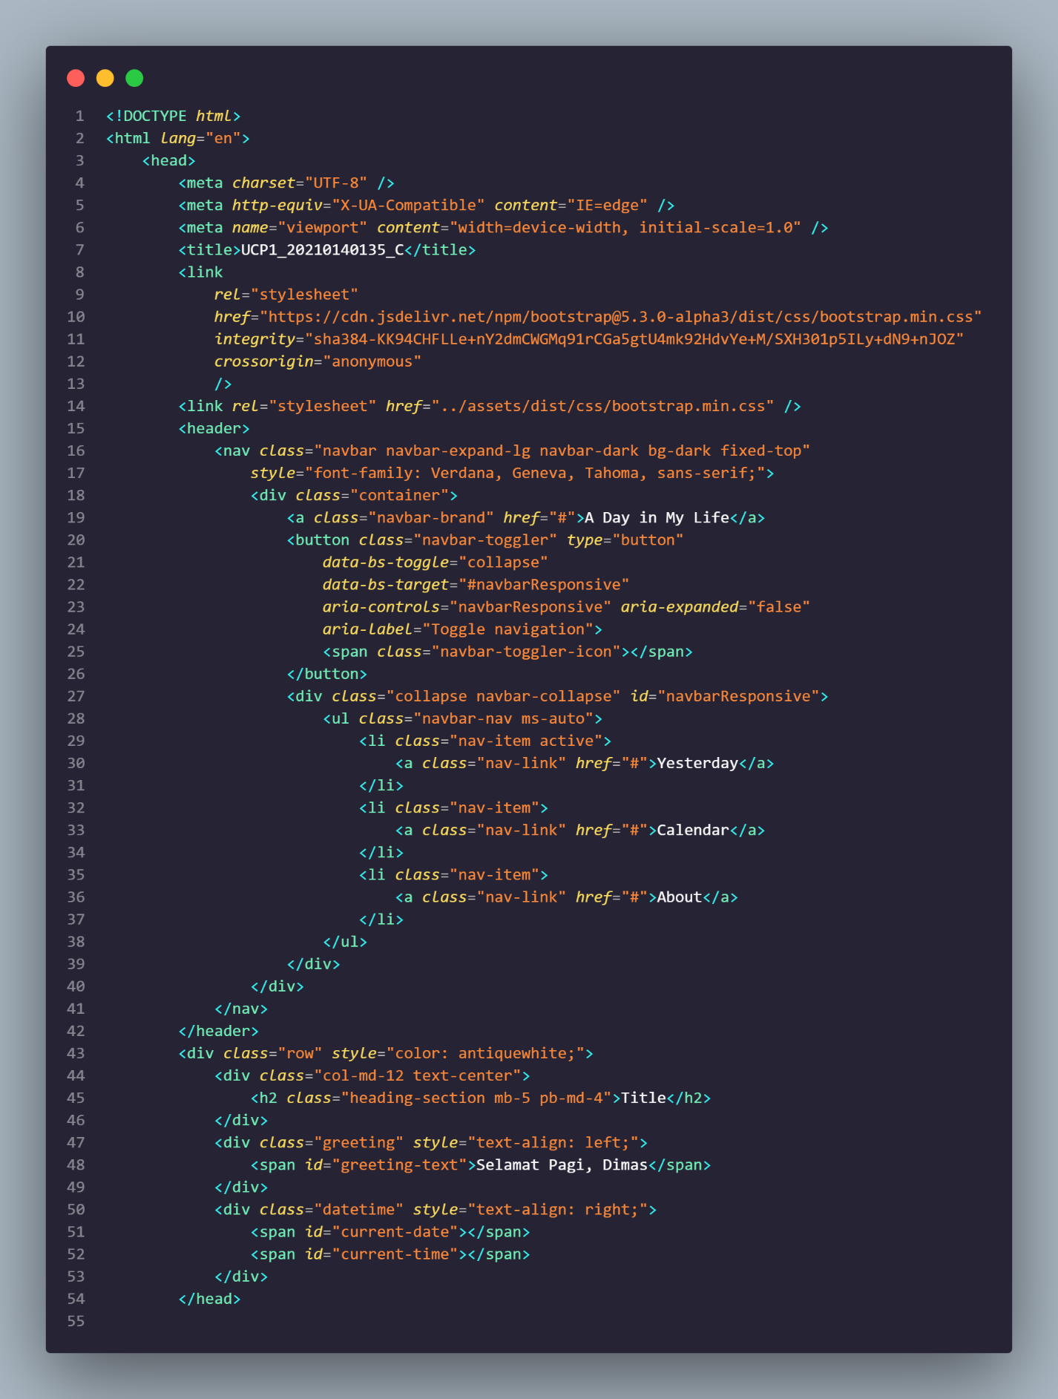

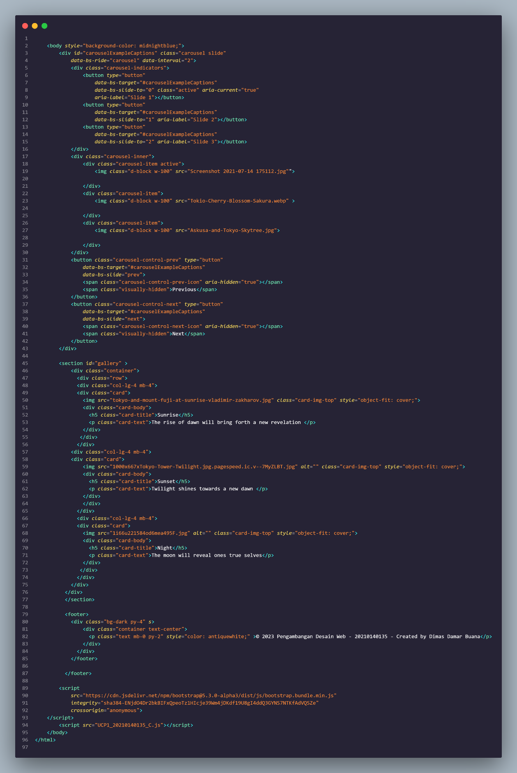

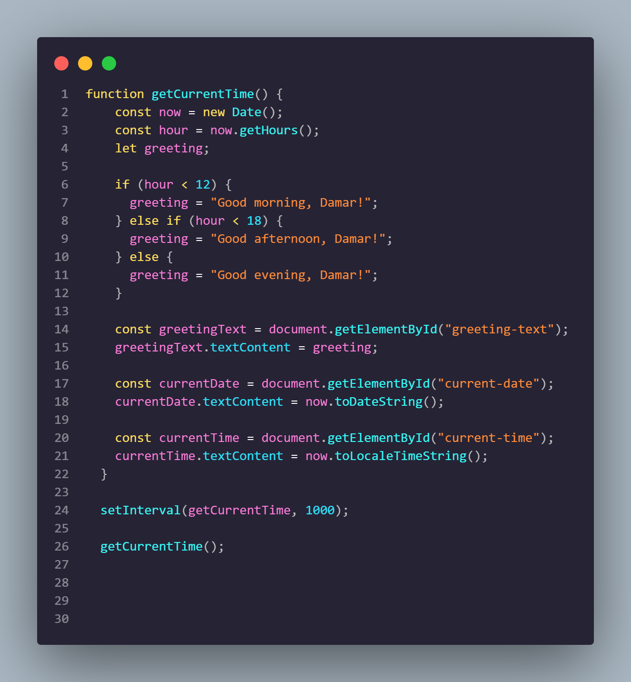

1. Hasil

